b Problem 1

part a

i)

null(AT) = [[1, -3/2, 1]T]

range(A) = [[1,2,2]T, [2,2,1]T]

ii)

dim(null(AT)) + dim(range(A)) = 3

iii)

b_r = 5/17 * [3,4,3]^T

b_n = 1/17 * [2,-3,2]^T

part b

i)

A^T A = [[9,8], [8,9]]

by inspection the eigenvalues are 17 and 1

then eigenvectors are[1,1]^T and [1,-1]^T

ii)

The V = 1/sqrt(2) * [[1,1], [1,-1]]x

note that normalization is not strictly required here, however since the next part ask us to calculate the SVD, I think it would be wise to do it here.

iii)

u_1 = [[1,2],[2,2],[2,1]] * [1,1]T / sqrt(2) / sqrt(17) = [3, 4, 3]T / sqrt(34)

u_2 = [[1,2],[2,2],[2,1]] * [1,-1]T /sqrt(2) / 1 = [-1, 0, 1]T / sqrt(2)

u_3 = u_1 cross product u_2 = [4, -6, 4]T / sqrt(68) = [2, -3, 2]T / sqrt(17)

8

So

S = [[sqrt(17), 0], [0,1],[0,0]]

U = 1/sqrt(34) * [[3, -sqrt(17), 2*sqrt(2)], [4, 0, -3*sqrt(2)], [3, sqrt(17), 2*sqrt(2)]]

iii)

singular values are sqrt(17) and 1, l2 norm is sqrt(17)

c

i)

if Bx = 0 then (BT B)x = BT(Bx) = BT 0 = 0

if BTBx = 0 then xTBTBx = 0 so (Bx)T(Bx) = 0, so Bx = 0

Then we know that null(B) is the same as null(BTB)

ii)

As we have shown in i, null(B) is the same as null(BTB), then we have dim(null(B)) = dim(null(BTB))

And note that B has dimension m by n and BTB has dimension n by n.

Using rank nullity theorem:

rk(B) + nullity(B) = n = rk(BTB) + nullity(BTB)

And since we have nullity(B) = nullity(BTB)

We know that rk(B) = rk(BTB)

Alternatively:

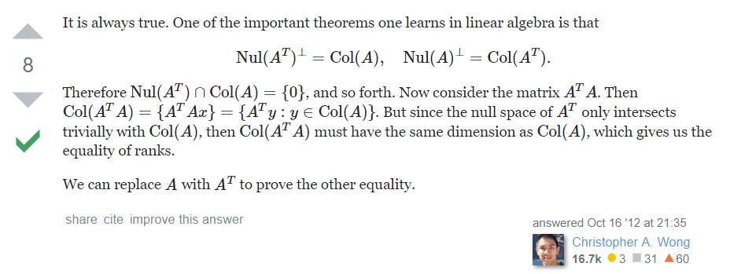

Problem 2:

Perform the QR decomposition as taguht by lecture gives us:

e_1 = [1,1,0] / sqrt(2)

e_2 = [1, -1, 2] / sqrt(6)

e_3 = [-1, 1, 1] / sqrt(3)

This process is very error prone, so do be careful.

Calculate the element in R as follows:

e_1 * a_1 = 2 / sqrt(2)

e_1 * a_2 = 1 / sqrt(2)

e_1 * a_3 = 2 / sqrt(2)

e_2 * a_2 = 3 / sqrt(6)

e_2 * a_3 = 2 / sqrt(6)

e_3 * a_3 = 1 / sqrt(3)

Then calculate Q^T * [1,1,2]^T = [2 / sqrt(2), 4 / sqrt(6), 2 / sqrt(3)]

We then use backward substitution to solve for x_1, x_2 and x_3. You can check their values are correct by substitute them in. They should be x_1 = -1, x_2 = 0 and x_3 = 2.

b)

i)

A = [[1,1], [1,c]] This can be obtained by setting A = [[a_1, a_2], [a_3, a_4]], the solve the a_1, a_2, a_3 and a_4. Then if we assume A is symmetric we will get an A that is easy to work with.

When we have A we can get its hessian which is 2A since A is symmetric. If it has a minimum then it should be positive definite. So c - 1 > 0. So c > 1.

Some more context around this solution:

<https://ocw.mit.edu/courses/sloan-school-of-management/15-084j-nonlinear-programming-spring-2004/lecture-notes/lec4_quad_form.pdf>

ii)

We then represent the later part in the following form:

f(x,y) = [x, y] A [x,y]^T - 2b^T[x, y]^T + c + 2015 where A is the same as in i and b is [2, c+1]^T

We then solve for:

A [x, y]^T = b

This gives us x = 1 and y = 1.

And f(1,1) = 2012 which is the minimum.